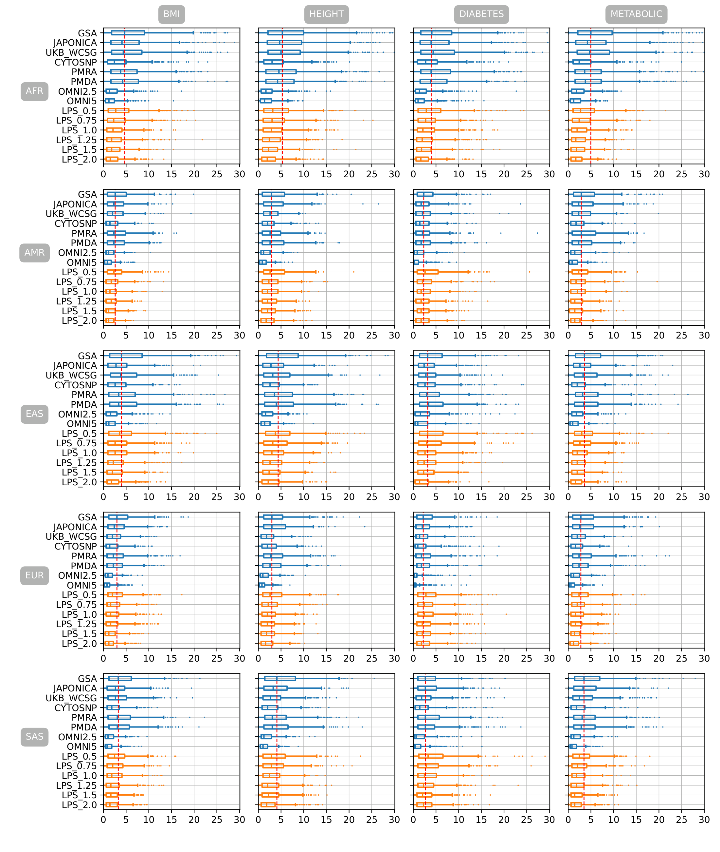

Figure S. 1 Mean absolute difference of percentile ranking between PGSs estimated from imputed genotyping data of eight genotyping arrays and six LPS coverages and PGS estimated from WGS in 5 different populations with PRsice p-value setting of 5e-08

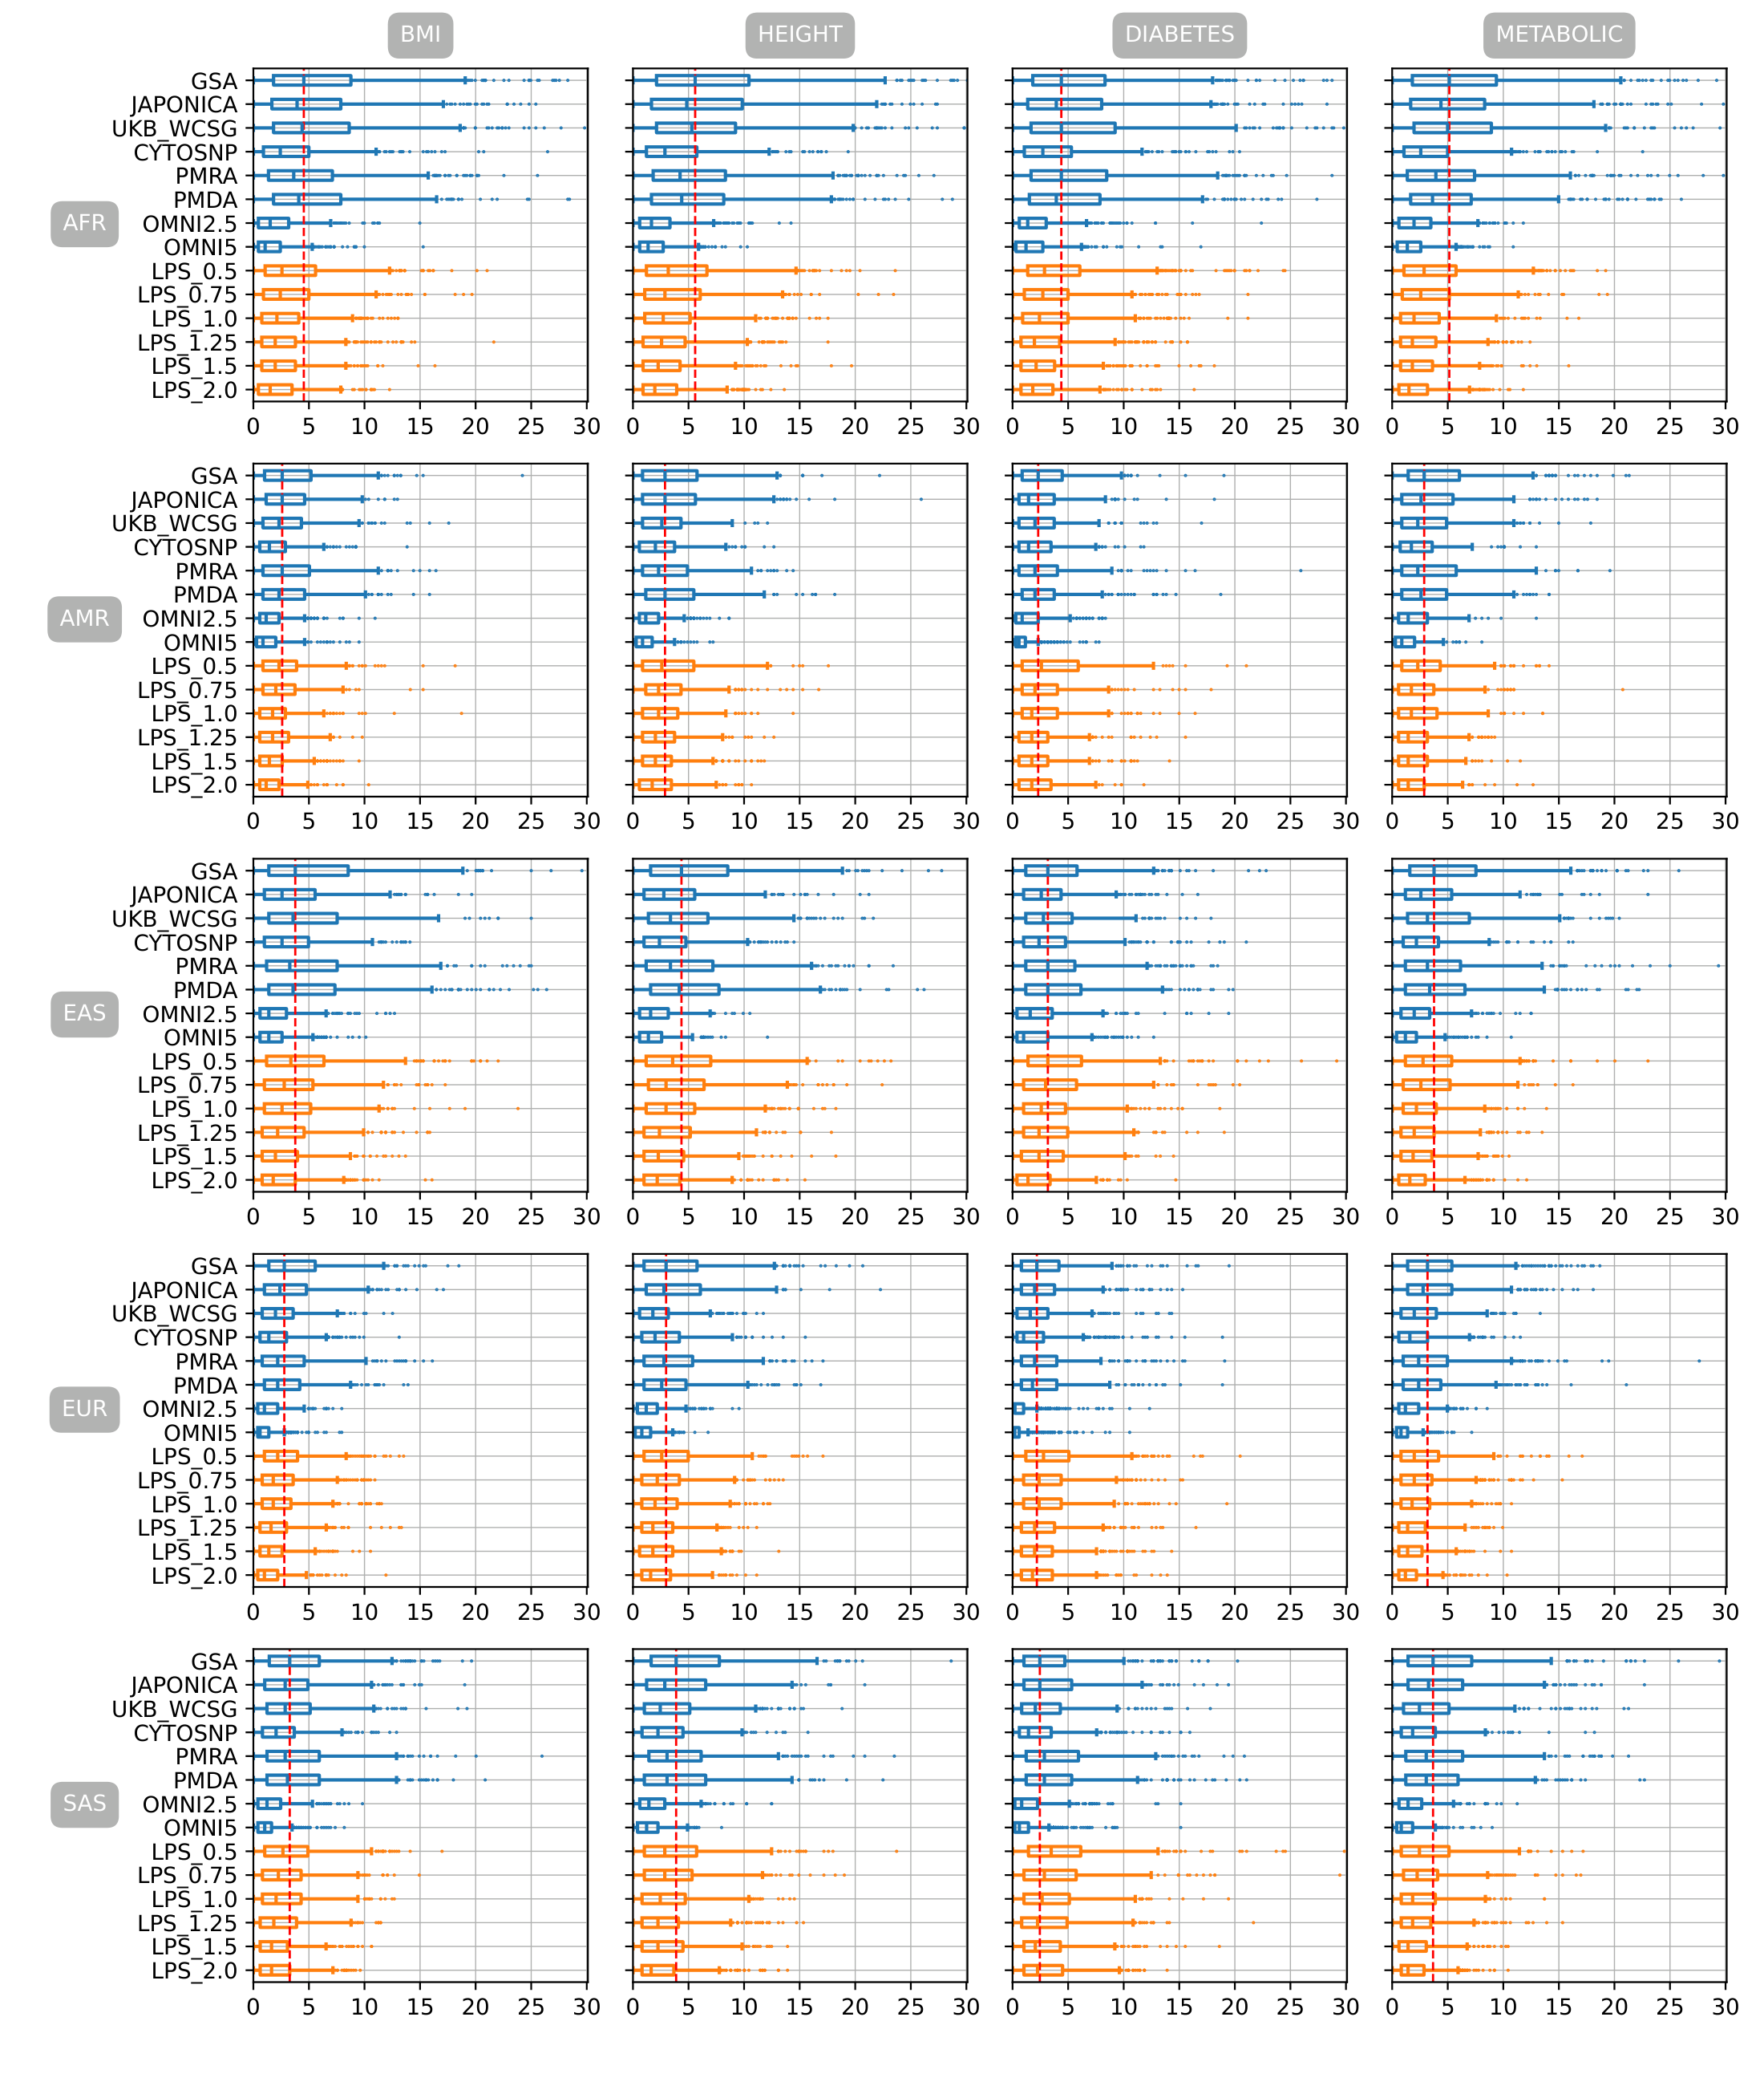

Figure S. 2 Mean absolute difference of percentile ranking between PGSs estimated from imputed genotyping data of eight genotyping arrays and six LPS coverages and PGS estimated from WGS in 5 different populations with PRsice p-value setting of 1e-07

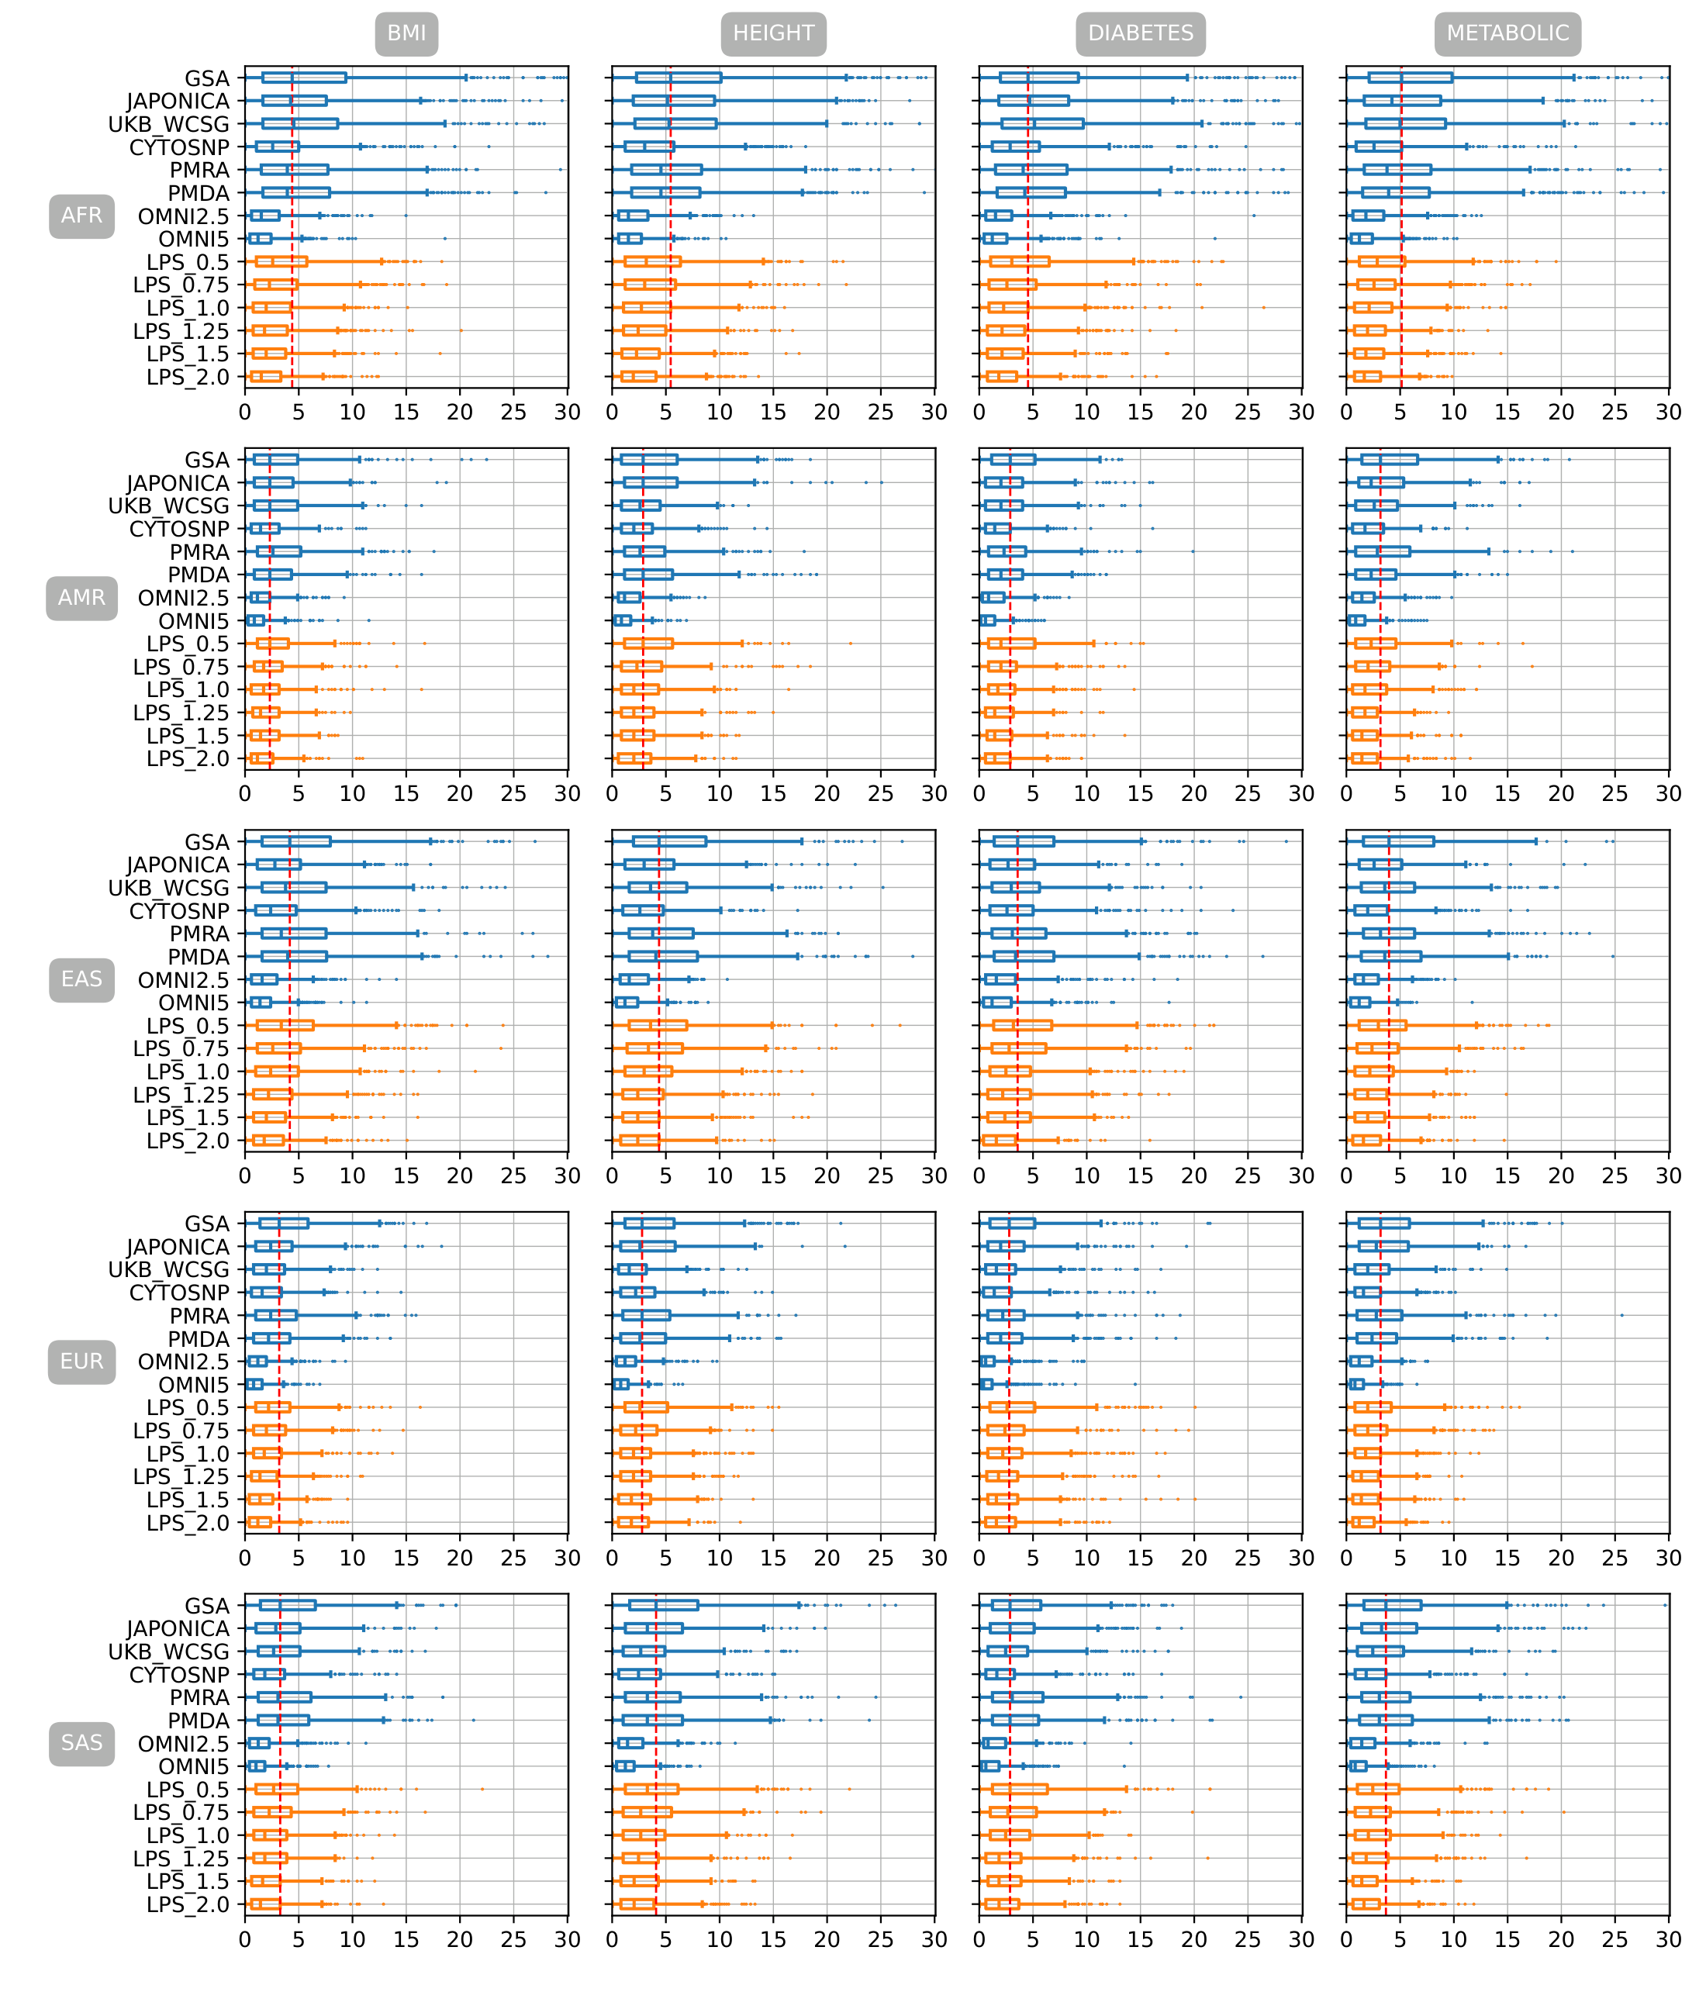

Figure S. 3 Mean absolute difference of percentile ranking between PGSs estimated from imputed genotyping data of eight genotyping arrays and six LPS coverages and PGS estimated from WGS in 5 different populations with PRsice p-value setting of 1e-06

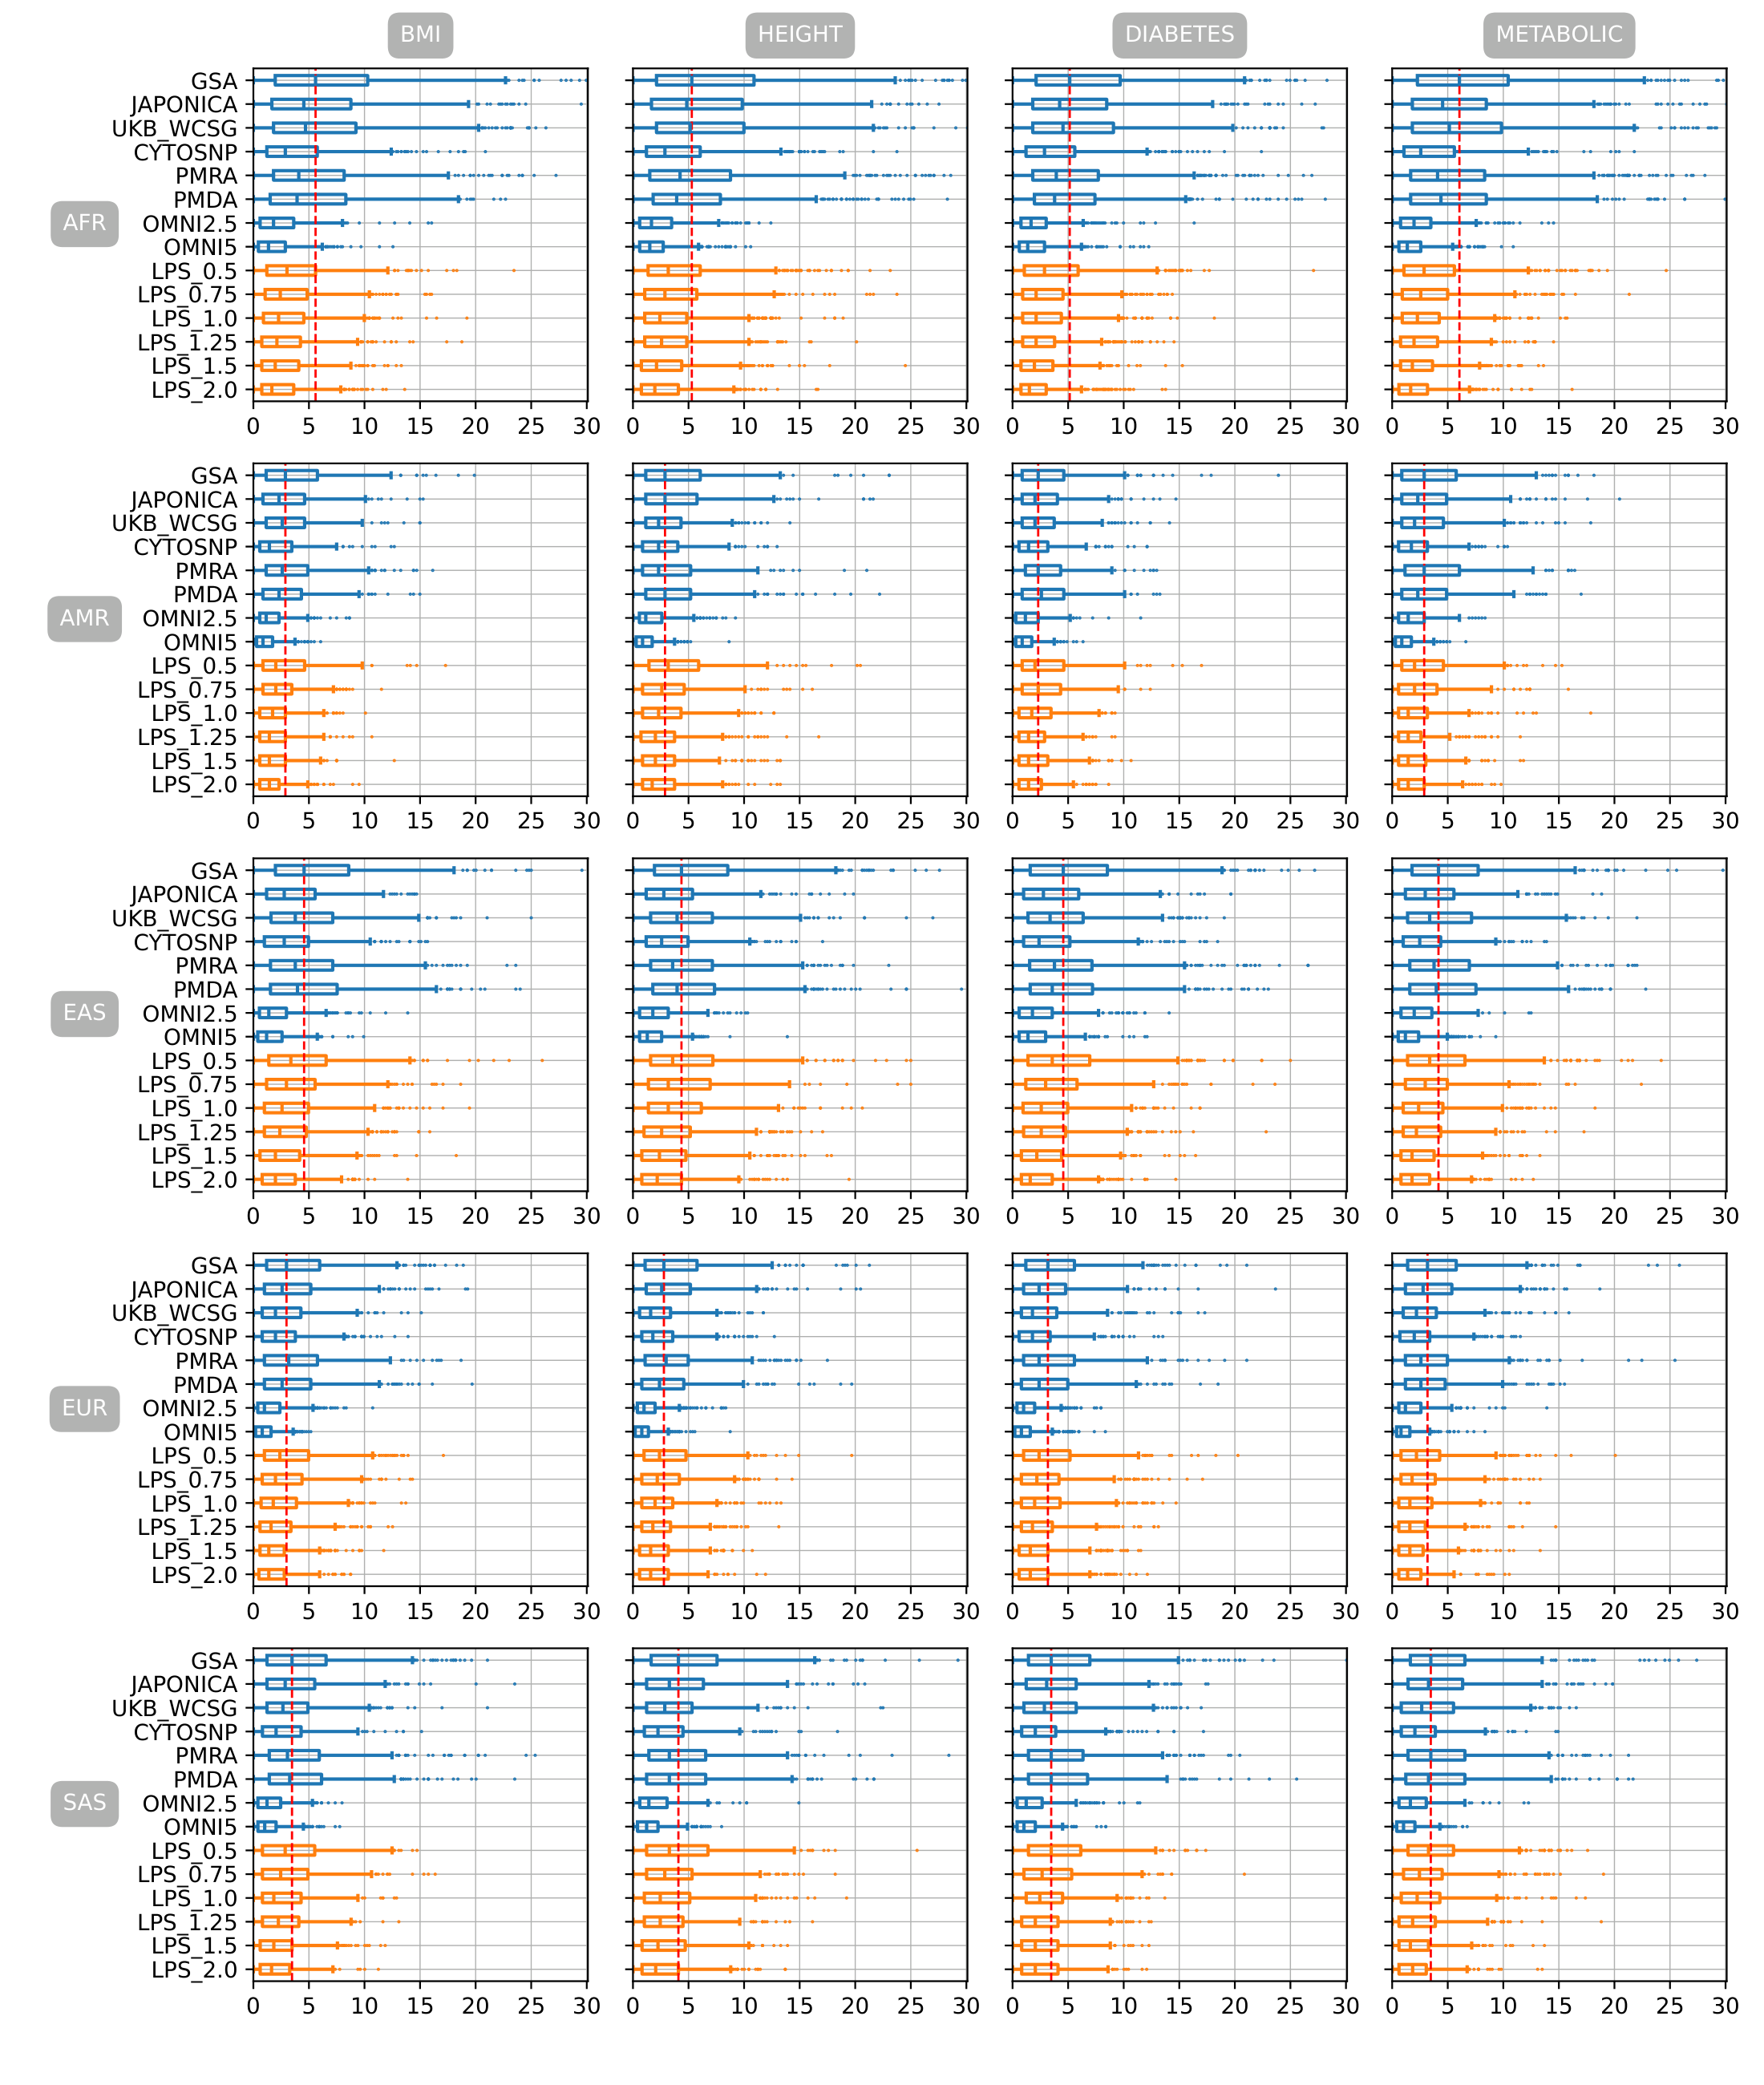

Figure S. 4 Mean absolute difference of percentile ranking between PGSs estimated from imputed genotyping data of eight genotyping arrays and six LPS coverages and PGS estimated from WGS in 5 different populations with PRsice p-value setting of 0.0001

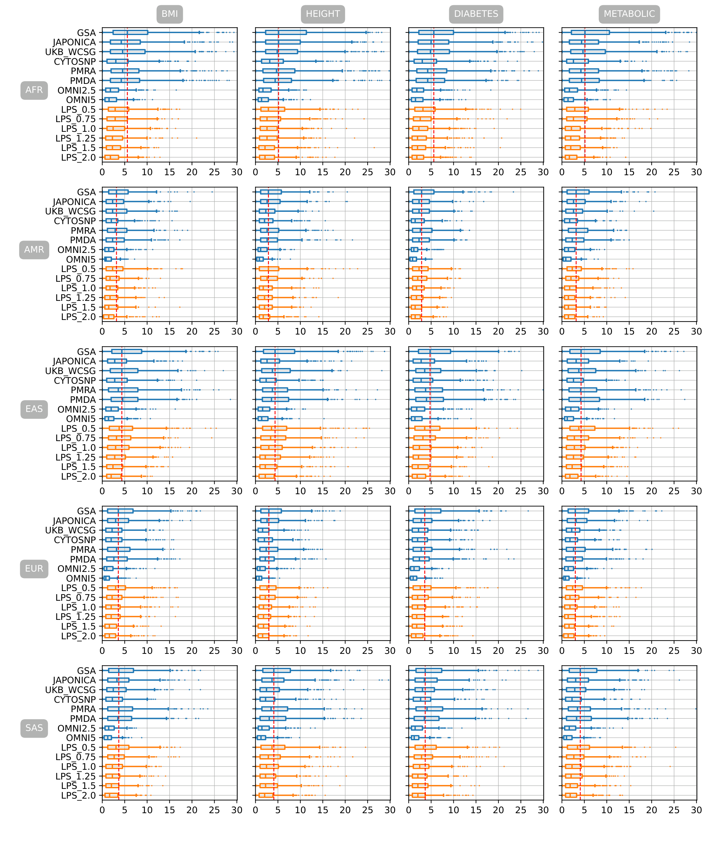

Figure S. 5 Mean absolute difference of percentile ranking between PGSs estimated from imputed genotyping data of eight genotyping arrays and six LPS coverages and PGS estimated from WGS in 5 different populations with PRsice p-value setting of 0.001

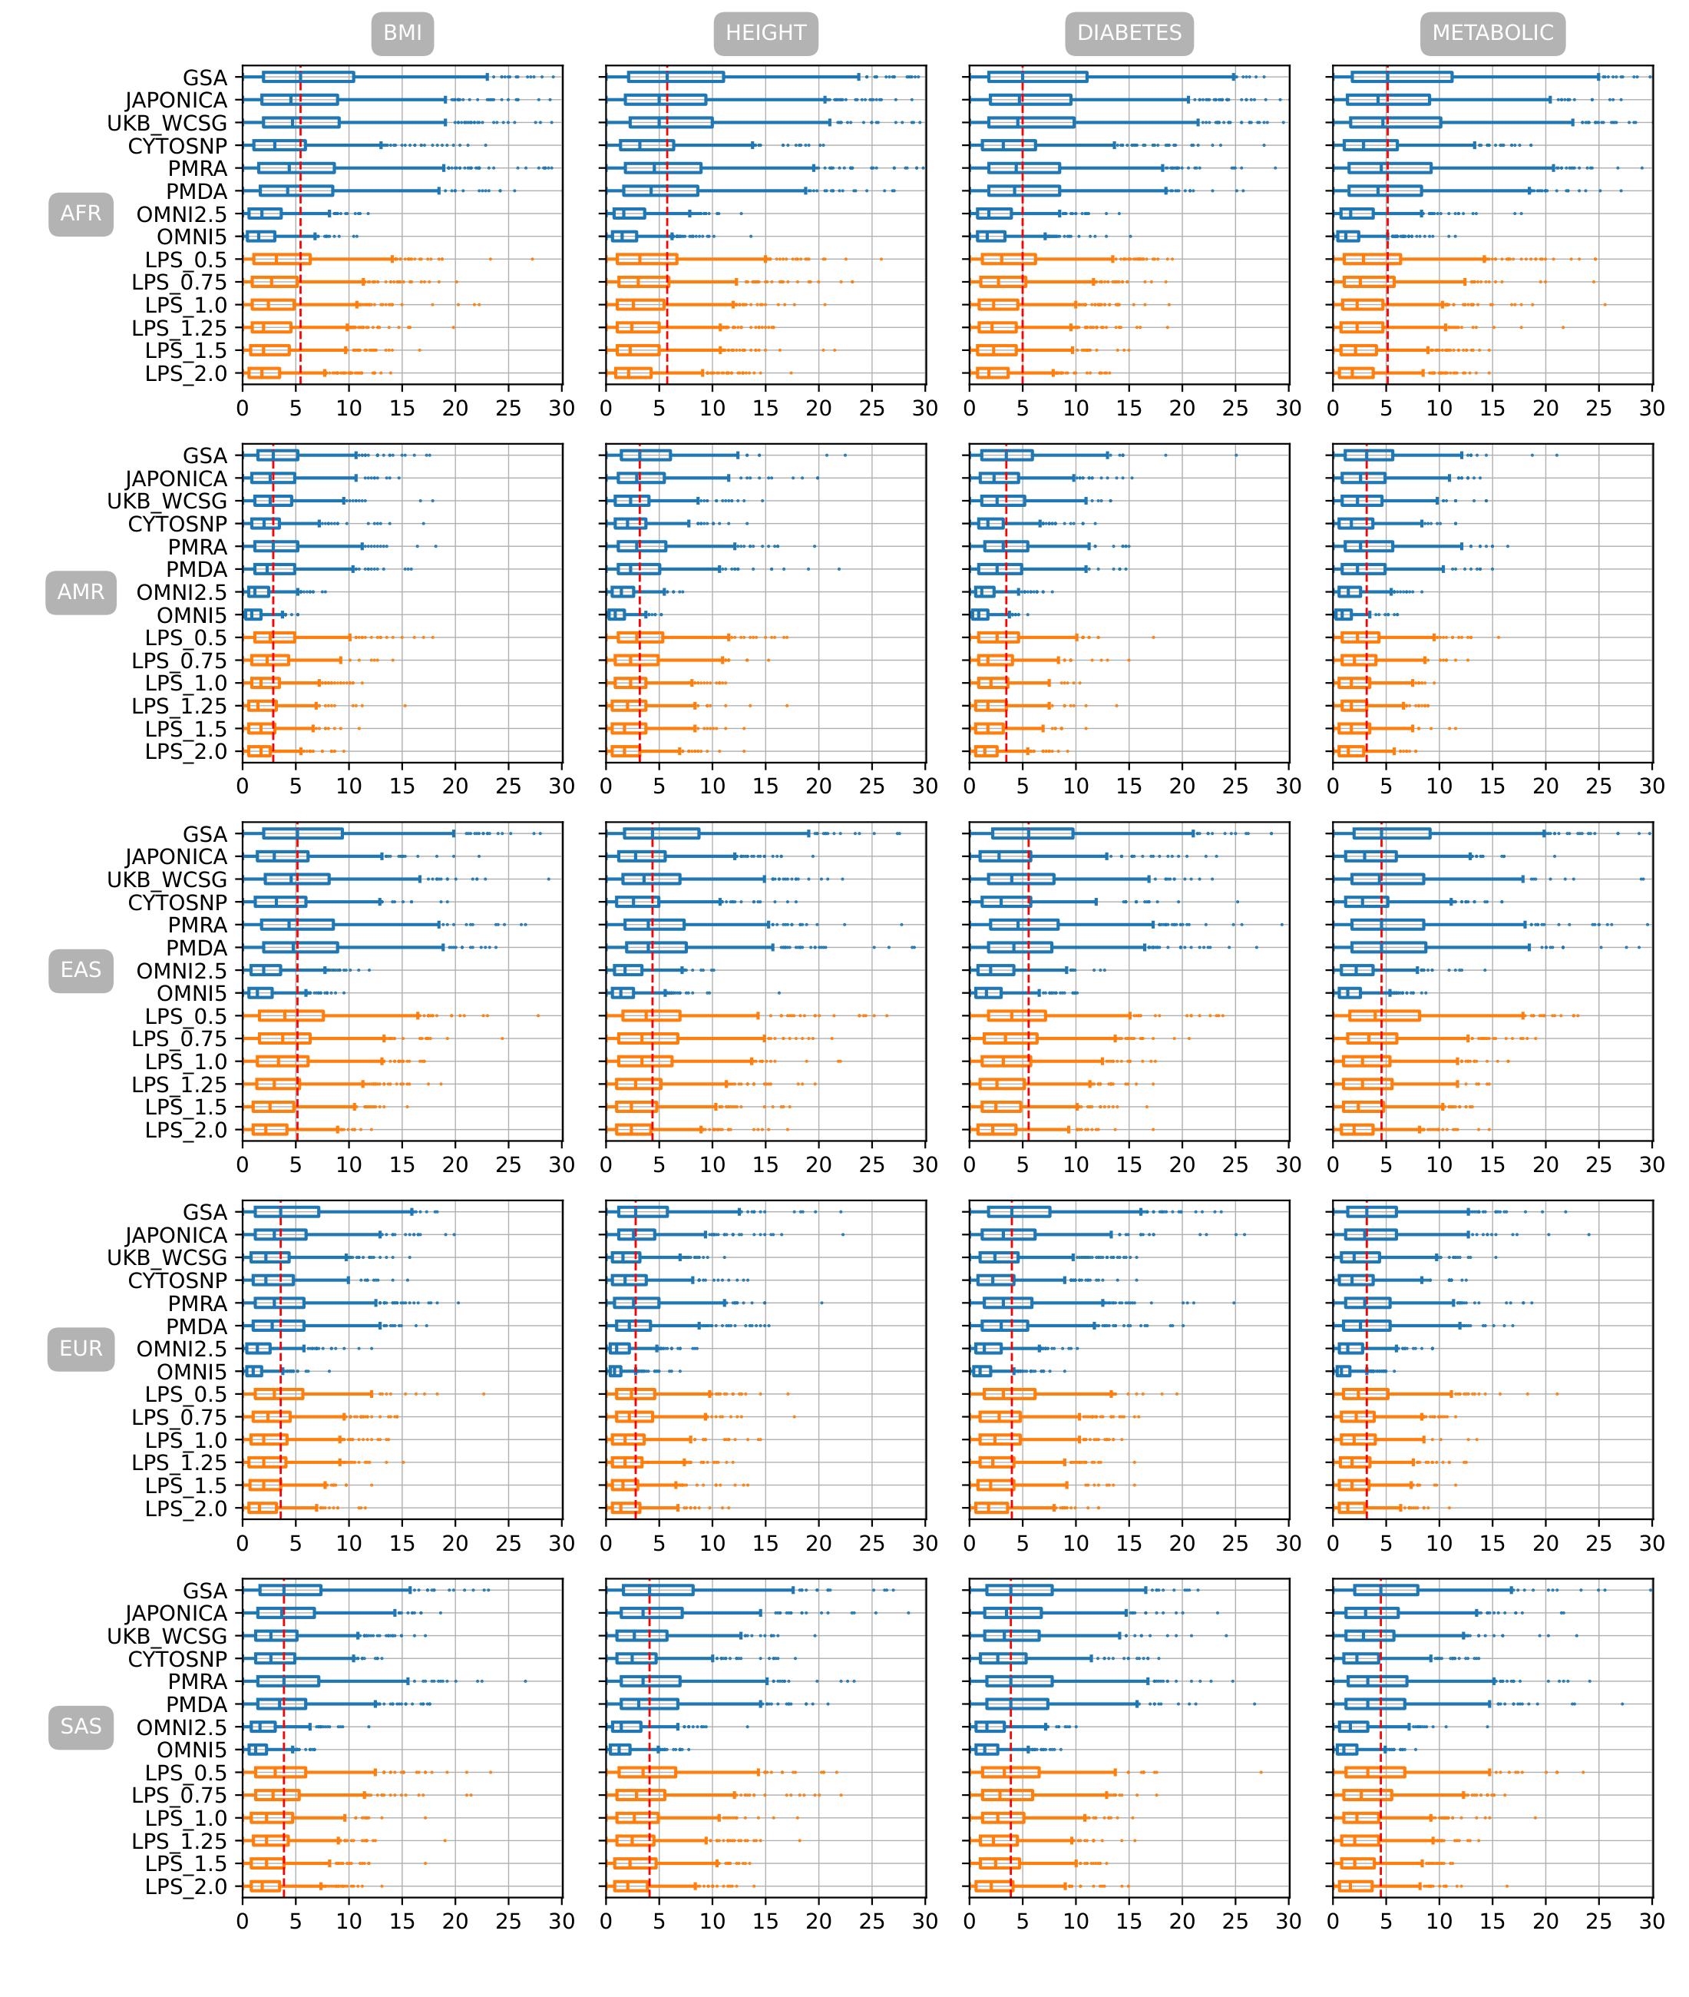

Figure S. 6 Mean absolute difference of percentile ranking between PGSs estimated from imputed genotyping data of eight genotyping arrays and six LPS coverages and PGS estimated from WGS in 5 different populations with PRsice p-value setting of 0.01

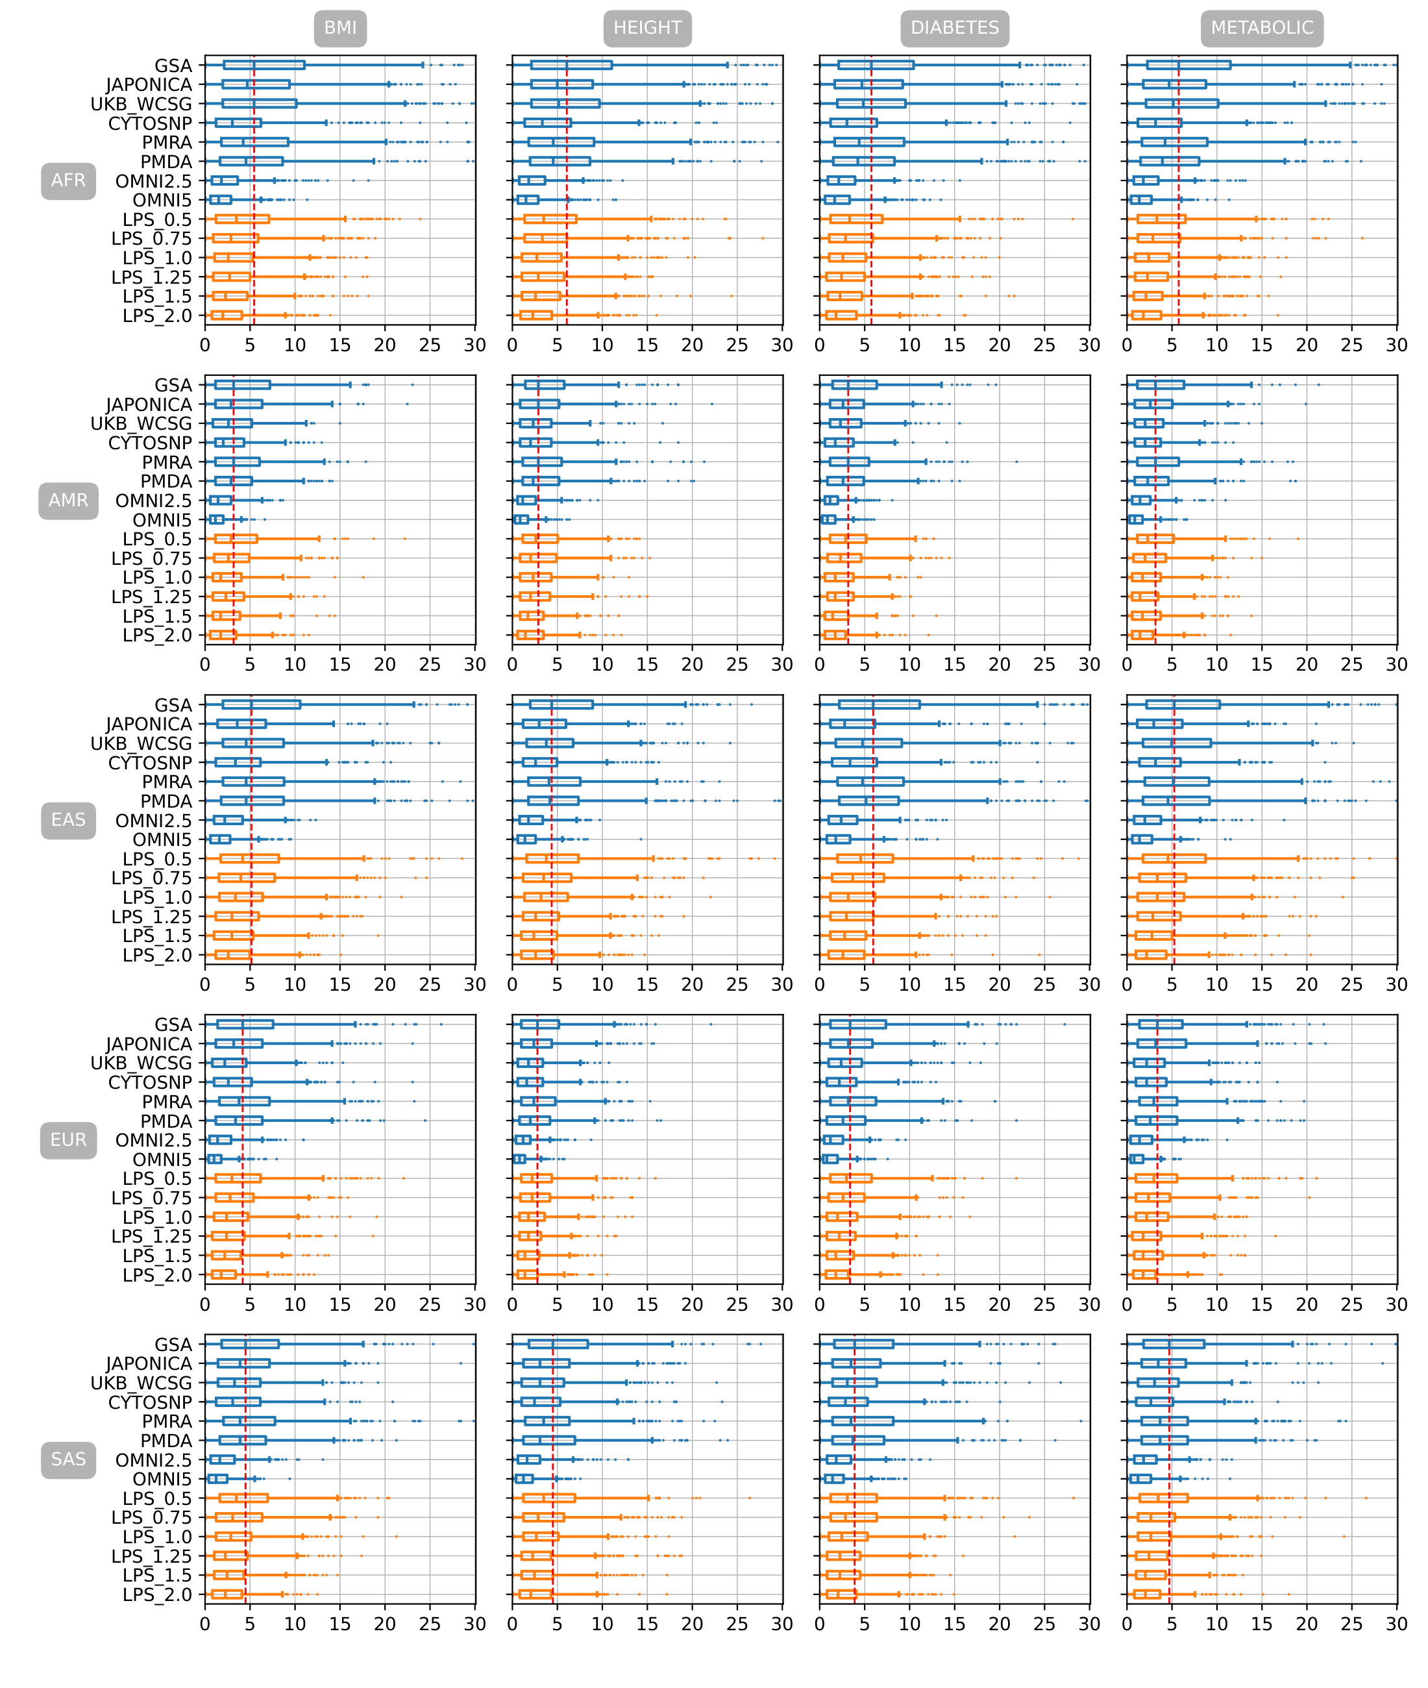

Figure S. 7 Mean absolute difference of percentile ranking between PGSs estimated from imputed genotyping data of eight genotyping arrays and six LPS coverages and PGS estimated from WGS in 5 different populations with PRsice p-value setting of 0.1

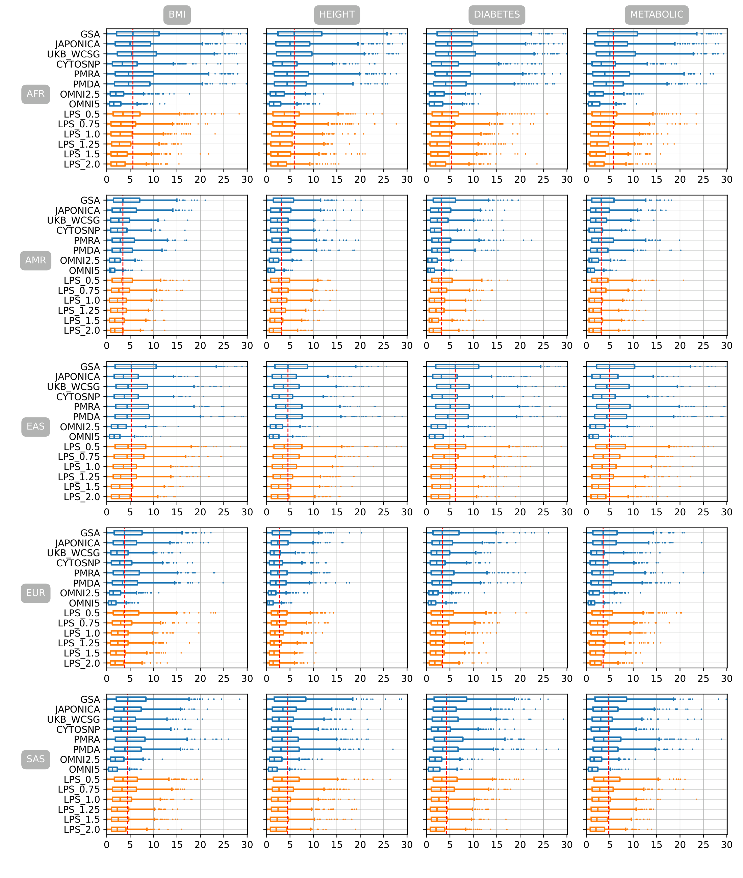

Figure S. 8 Mean absolute difference of percentile ranking between PGSs estimated from imputed genotyping data of eight genotyping arrays and six LPS coverages and PGS estimated from WGS in 5 different populations with PRsice p-value setting of 0.2

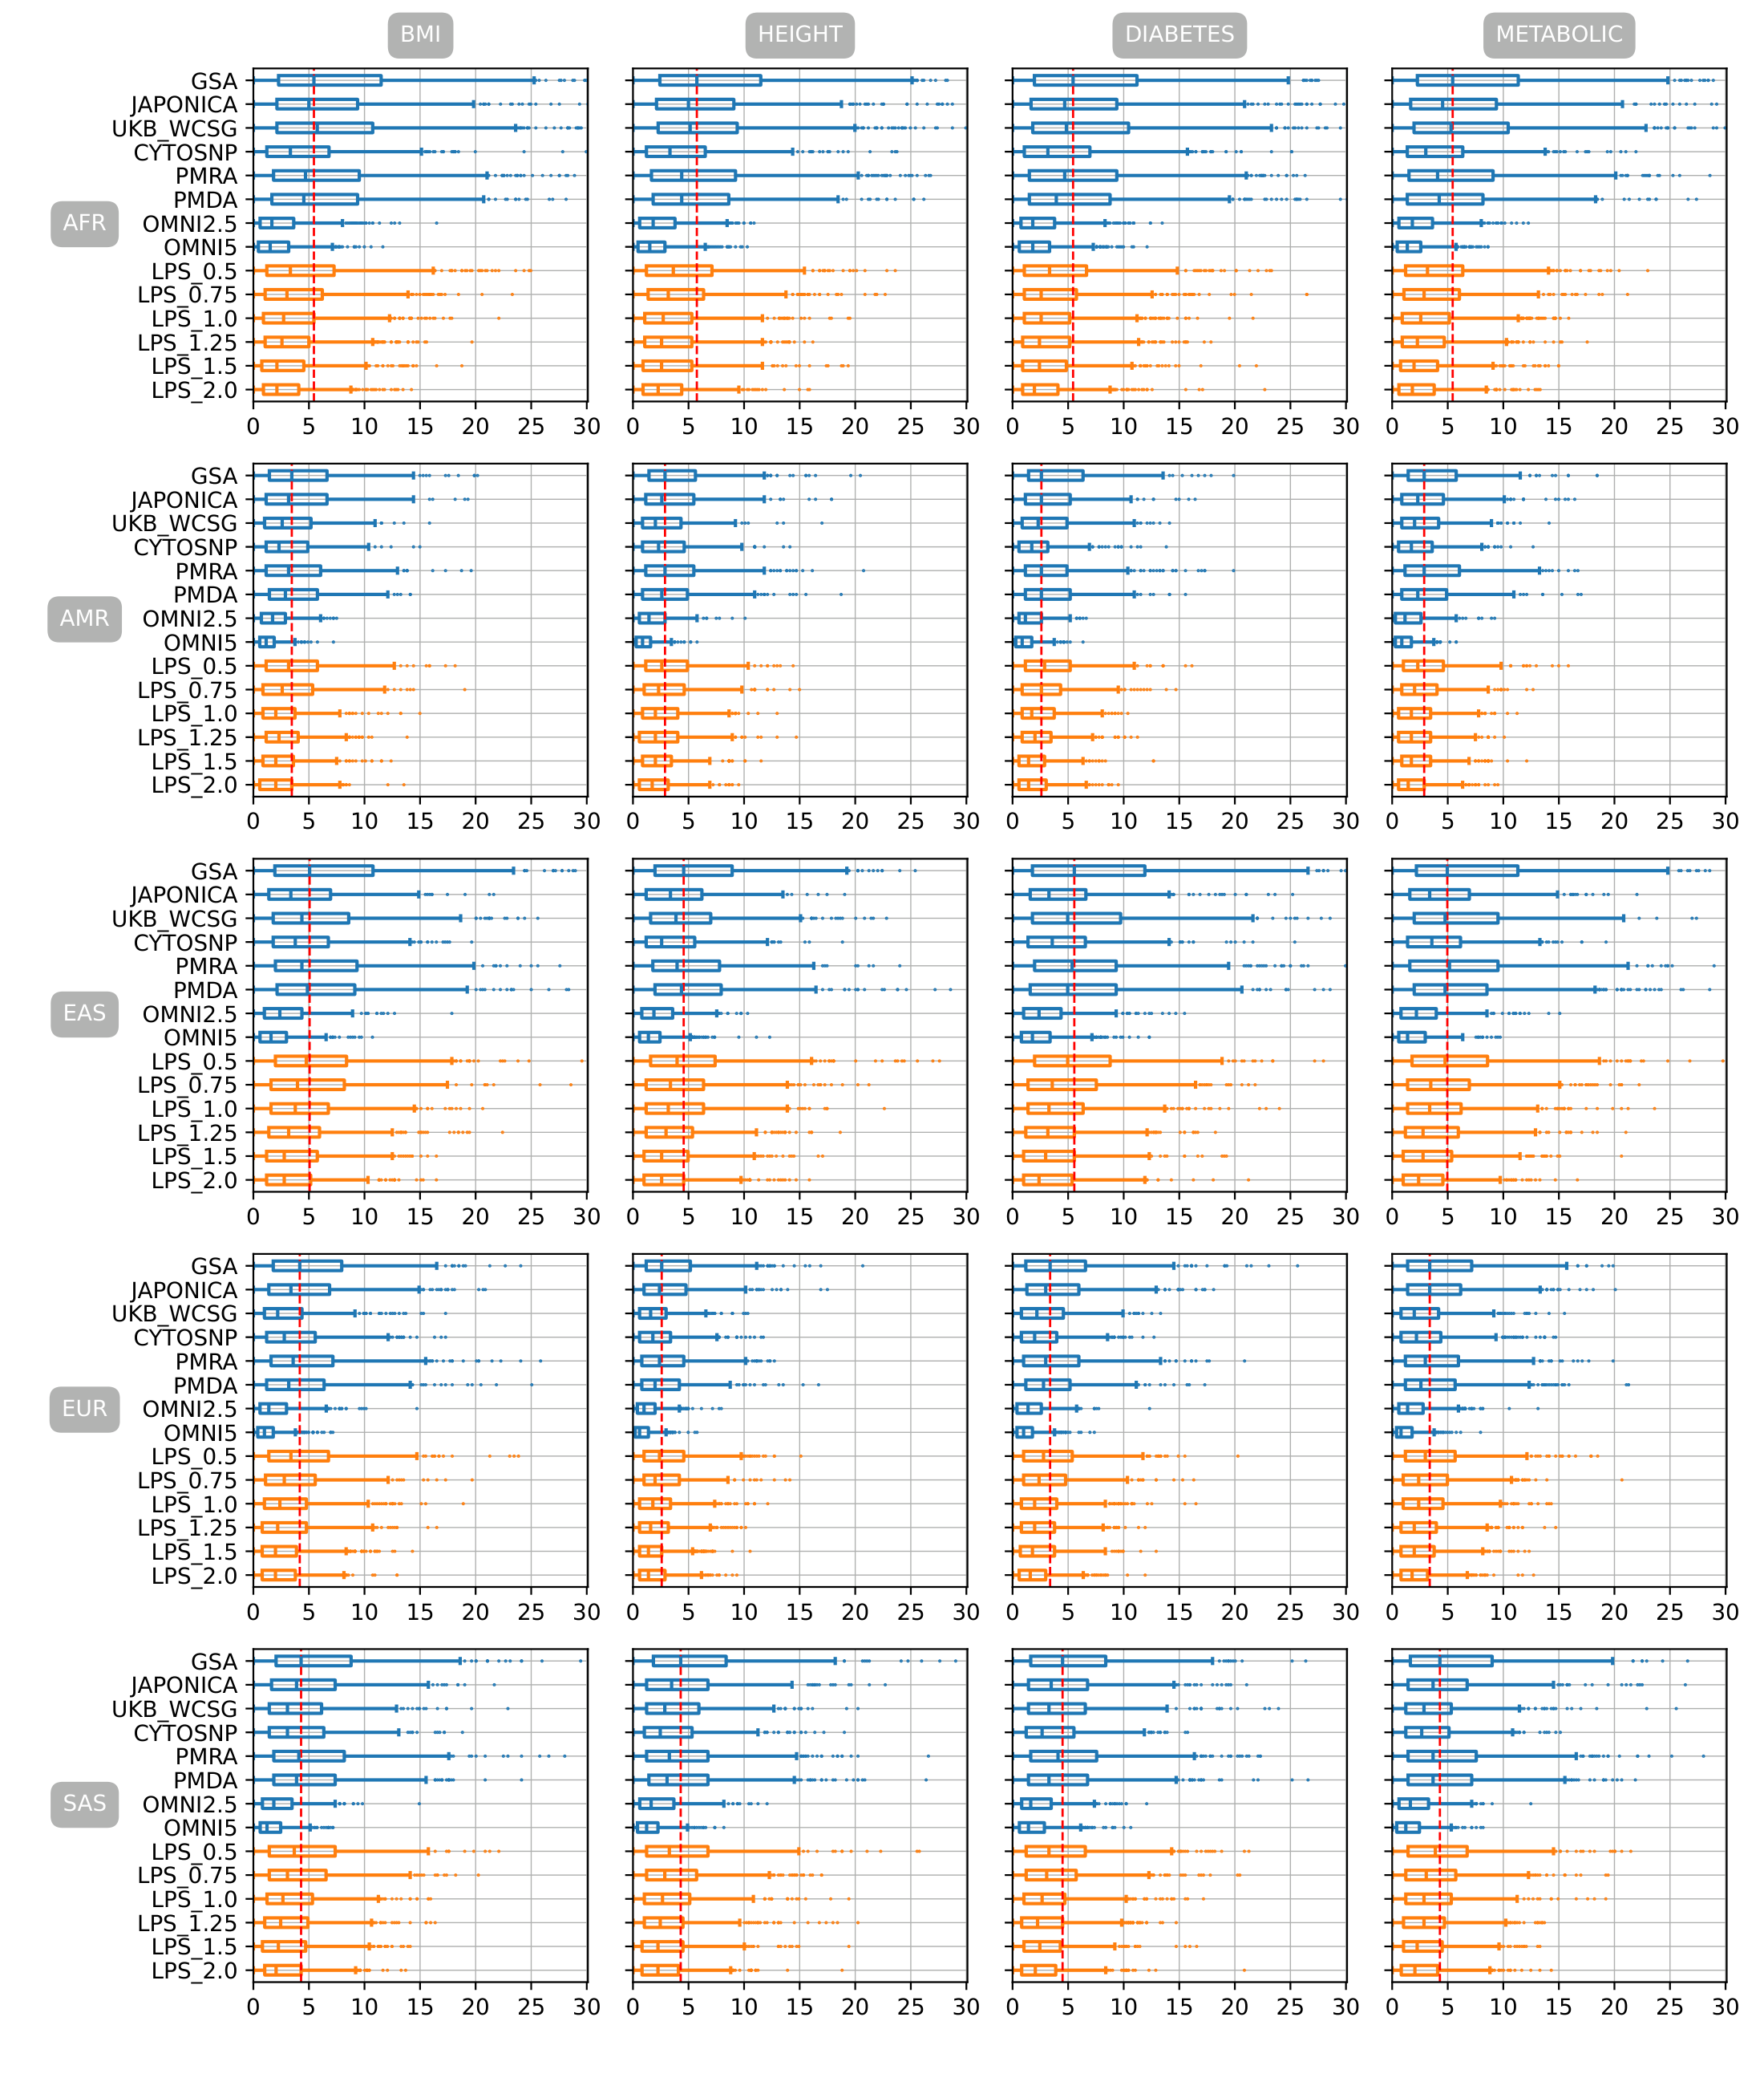

Figure S. 9 Mean absolute difference of percentile ranking between PGSs estimated from imputed genotyping data of eight genotyping arrays and six LPS coverages and PGS estimated from WGS in 5 different populations with PRsice p-value setting of 0.3

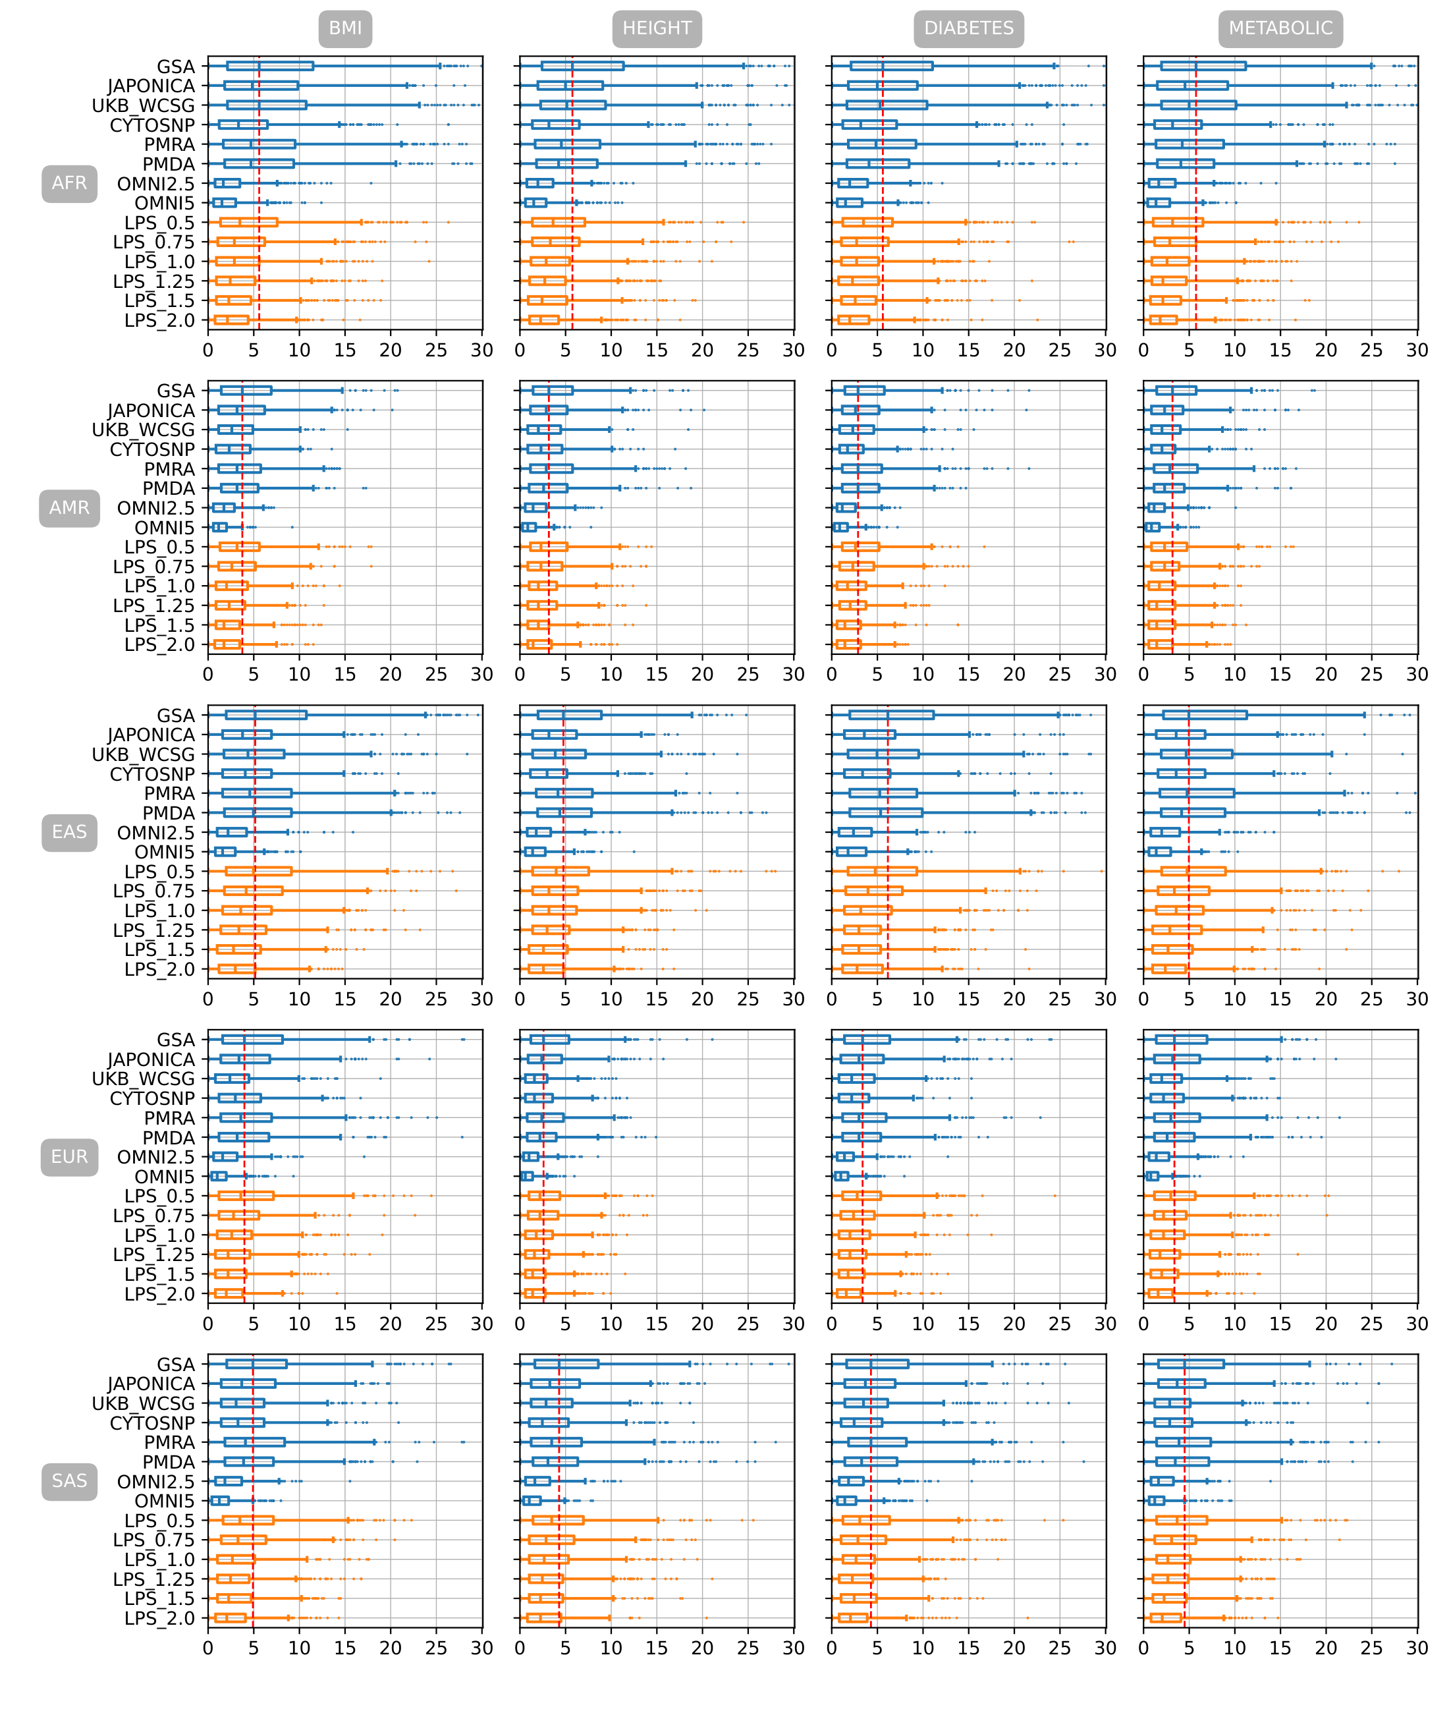

Figure S. 10 Mean absolute difference of percentile ranking between PGSs estimated from imputed genotyping data of eight genotyping arrays and six LPS coverages and PGS estimated from WGS in 5 different populations with PRsice p-value setting of 0.5

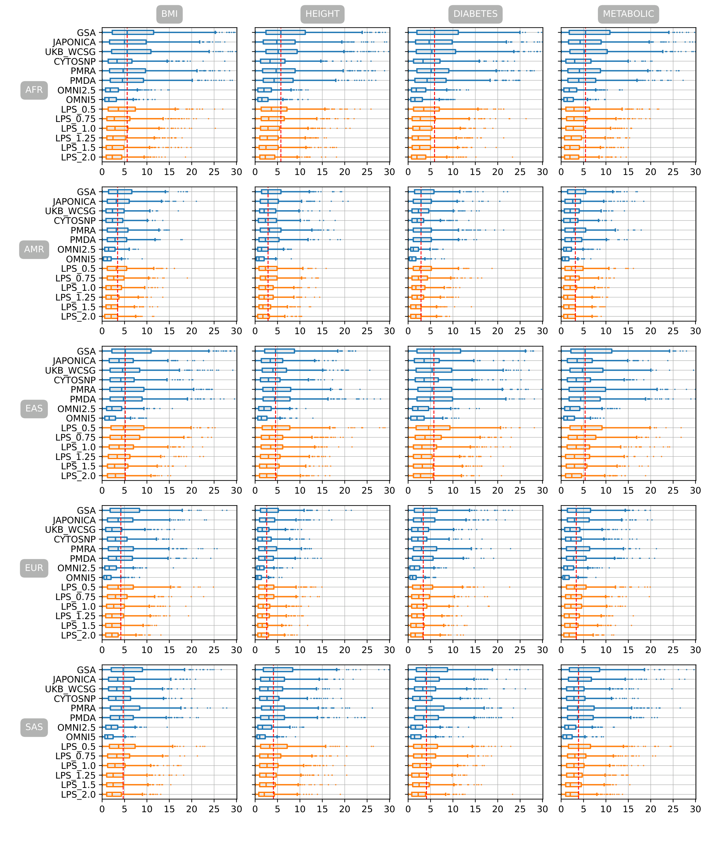

Figure S. 11 Mean absolute difference of percentile ranking between PGSs estimated from imputed genotyping data of eight genotyping arrays and six LPS coverages and PGS estimated from WGS in 5 different populations with PRsice p-value setting of 1